write a few paragraphs on how audio data is processed and learned

Sound is produced by vibration of an object
Vibrations determine oscillation of air molecules
Alternation of air pressure causes a wave

y(t)= A Sin (2 pi f t + fi)

ADC sample rate: we take more than 40000 amplified points in a second

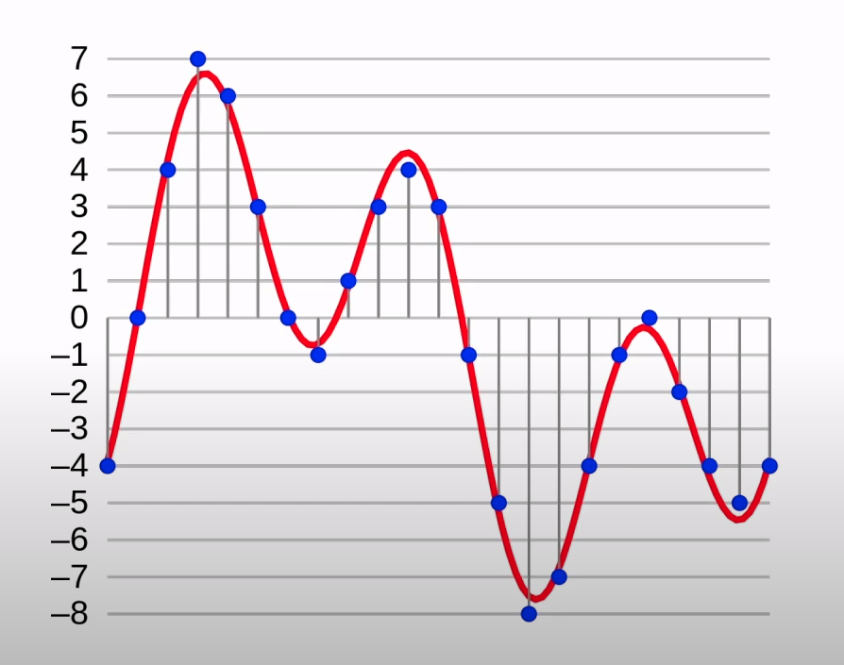

Fourier transform

Decompose complex periodic sound into sum of sine waves oscillating at different frequencies.
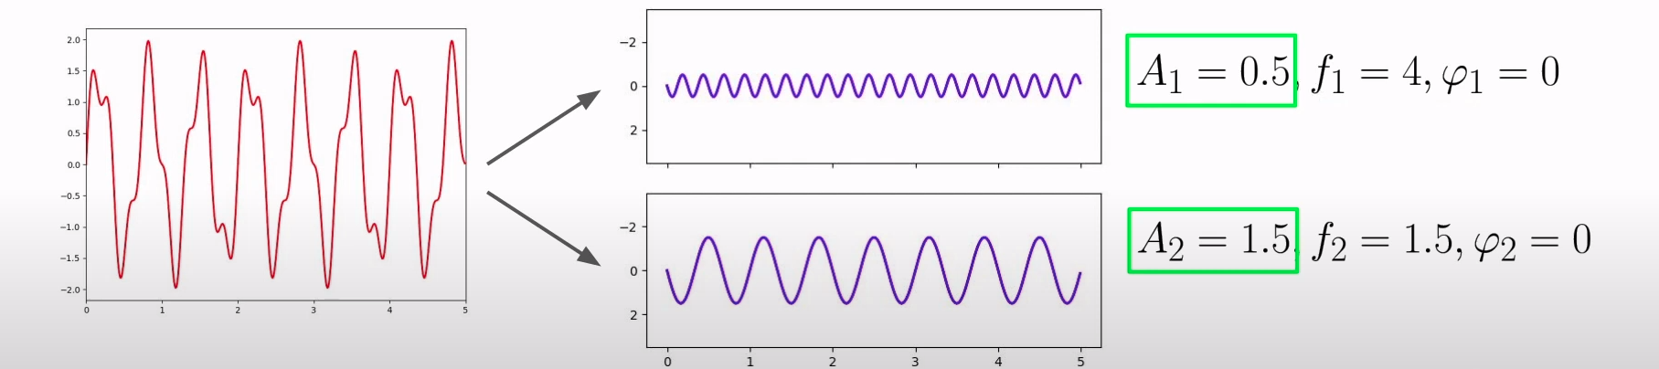

Deep learning for audio data is based on Spectrogram (db)

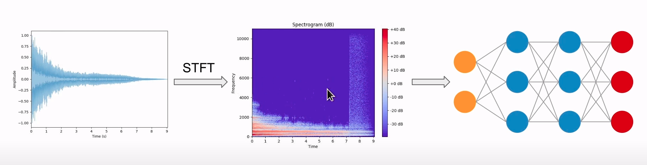

New one, Mel Frequency Cepstral Coefficients (MFCC)

Capture timbral/textural aspects of sound
Frequency domain feature
Approximate human auditory system
13 to 40 coefficients (13 is the best depending on my experiment)
Calculated at each frame

MFCC sample rate: we take more than 20300 amplified points in a second
